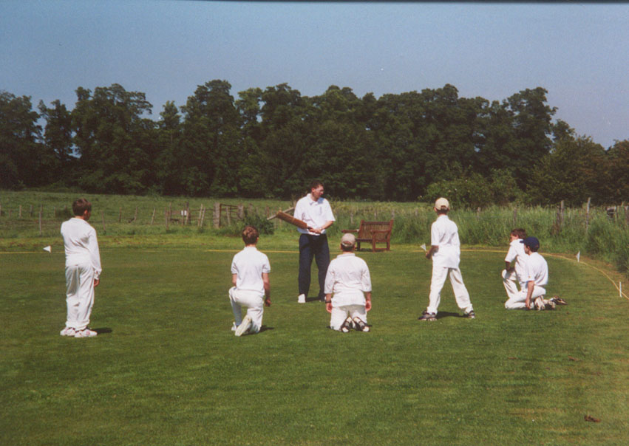
Come along to our special ‘Discover Cricket’ session at our fabulous ground at Home Farm.
Open to juniors of all ages, both boys AND girls are welcome. We will practice cricket skills, play some ‘Kwik Cricket’ (for younger juniors) and have a short talk about junior cricket at North Mymms Cricket Club

Best of all it is FREE!

If the weather is bad, we will arrange activities for another date but will still give the talk (it will just be a bit longer!)

Just come along but if you would like further information please contact either
Jon Mather jonathanmather21@hotmail.com or
Chris Cook chris@littleheathchess.co.uk or visit our website www.northmymmscc.co.uk or
call Jon on 07845 733391

Sunday 22nd April
10:00 - 12:00

at

North Mymms Cricket Club
Home Farm
North Mymms Park
AL9 7TR

